UCAM Function & Accuracy Report
Function
- ■People Counting
- □Occupancy
- □Path Linking

- File Name: 202119000179_C_2021_08_17_08_24_01.AVI
- Date & Time: 2021/08/17 08:24~09:24
- Location: Advantech Lobby
- Device: UCAM-130B
- Number: 1
- Door Type: Automatic
- Door Width: 2.6M
- Door Height: 2.5M
- Install Height: 2.8M
- Installation Photo:
Door:
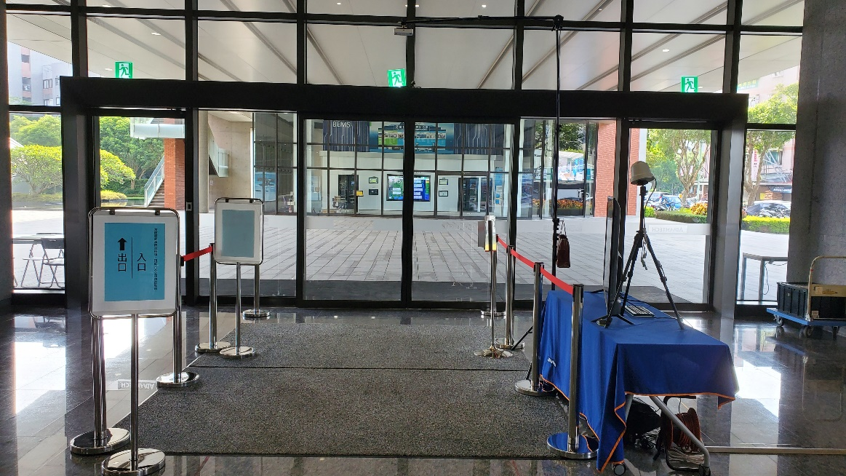

UCAM:
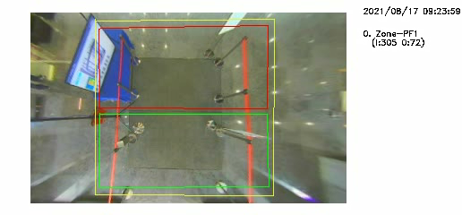
- UCAM Accuracy：
 | IN | OUT | Remark
Record | 305 | 72
Actual | 303 | 71
Accuracy | 99.34% | 98.61%

- Issue Time
Item | Time | Issue | Remark
1 | 08:59:02 | IN+1
2 | 09:07:36 | IN +1
3 | 09:14:22 | OUT +1

- Description
There are few count In +1 because and hand, how can we fix it?

